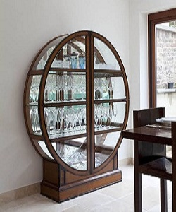

Simple Showcase

$98.03

Availability: In stock

### Description

Modern round wood glass Showcase with 8 sections and 2 glass doors. dining room crockery cupboard, this lacquered cabinet adds style to the bright room whilst serving as a secret shoe cupboard too small plastic trays mean this cupboard keeps hallway home decoration.